**Unit Testing**

* Unit testing is a level of software testing where individual units/components of software are tested. Unit testing in Magento 2 is useful to validate pieces of code.
* When you run Unit testing, a set of tests defined in the Magento 2 code base will be run. You can choose to run all tests or the specific tests you just chose.
* When you run Unit testing, a set of tests defined in the Magento 2 code base will be run. You can choose to run all tests or the specific tests you just chose.
* The unit testing process is separate and completely automatic without any manual handling.

**Use of unit test**

* The main objective of Magento Open-Source unit testing is **to isolate** written code to test and determine if it works as intended.
* Unit testing is an important step in the development process because if done correctly, it can help detect early flaws in code which may be more difficult to find in later testing stages.
* Tests Reduce Bugs in New Features
* Tests Reduce Bugs in Existing Features
* Tests Are Good Documentation
* Tests Reduce the Cost of Change
* Tests Allow Refactoring
* Tests Constrain Features
* Tests Defend Against Other Programmers
* Testing Makes Development Faster

How to run open-source unit test

bin/magento dev:tests:run unit

**Run this command before that we need to install phpunit to run testcases**  
  
**install phpunit via composer**

composer require --dev phpunit/phpunit

vendor/bin/phpunit --version

bin/magento dev:tests:run unit

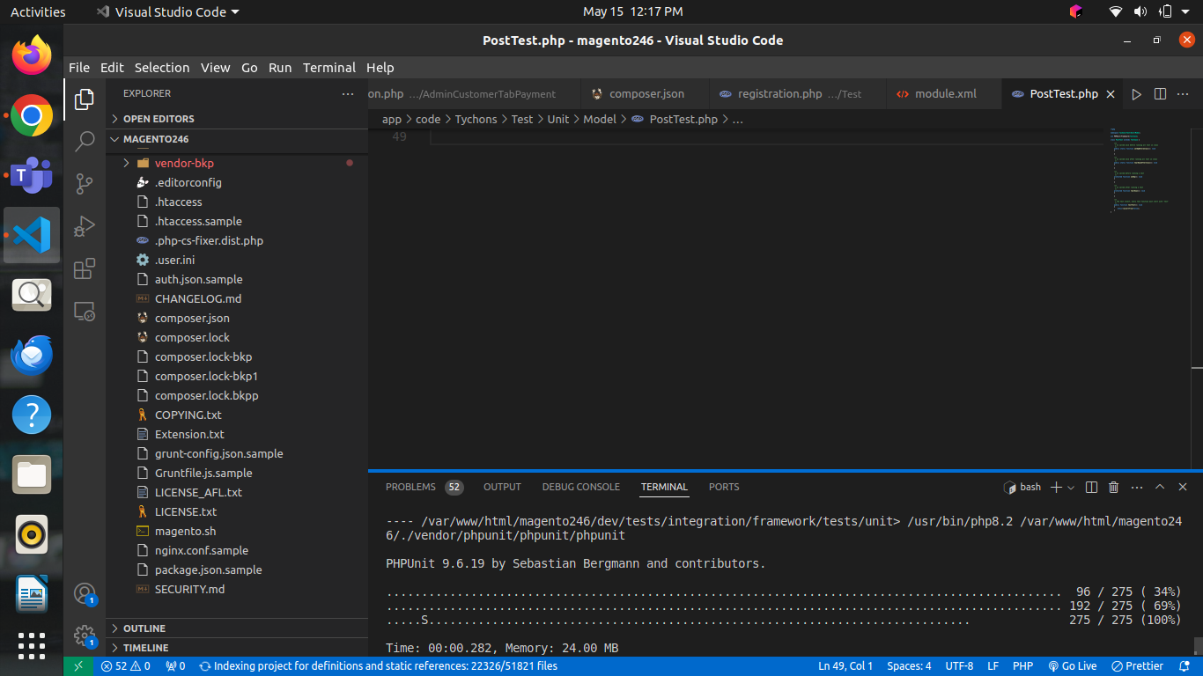

Facing some issue

File upgrading the file getting this below error

Could not validate a connection to OpenSearch. No alive nodes found in your cluster.

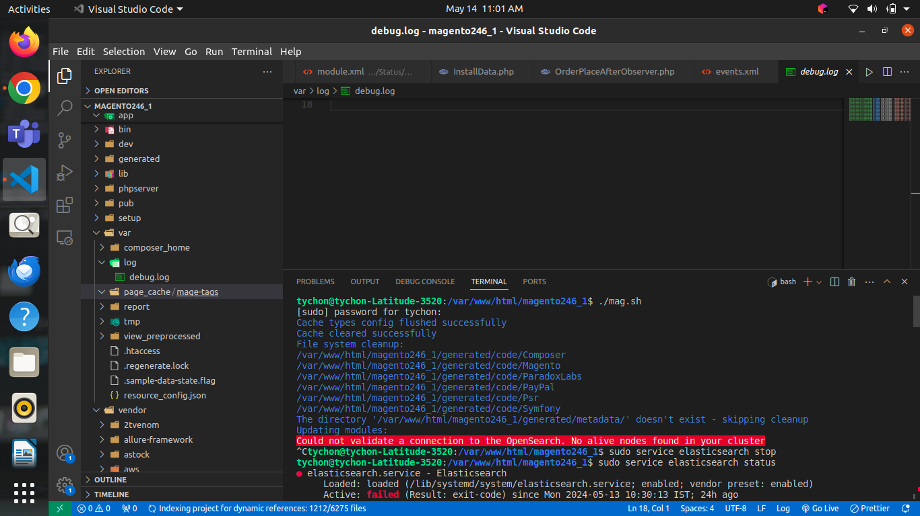

Procedure I have followed to clear issue:

Started and stopped the elastic search but error not yet cleared

Procedures to solve the issue:   
  
In terminal apply this command

sudo apt update

sudo apt install openjdk-8-jdk

sudo apt install apt-transport-https

wget -qO - https://artifacts.elastic.co/GPG-KEY-elasticsearch | sudo apt-key add -

echo "deb https://artifacts.elastic.co/packages/7.x/apt stable main" | sudo tee -a /etc/apt/sources.list.d/elastic-7.x.list

Install elastic search   
  
sudo apt update  
sudo apt install elasticsearch

sudo systemctl daemon-reload

sudo systemctl enable elasticsearch.service

sudo systemctl start elasticsearch.service

sudo systemctl restart elasticsearch.service

sudo systemctl stop elasticsearch.service

service elasticsearch status

After that the issue the error issue is cleared.